**Chapter 2 – Matrices**

**Theorem 2.2.22**

Let A be an m x n matrix

1. (AT)T = A
2. if be is also m x n matrix, then (A + B)T = AT + BT
3. if c is a scalar, then (cA)T = cAT
4. if B is n x p matrix, then (AB)T = BTAT

***Matrix Inverse* -**

Let A be a square matrix of order n.

Then A is said to be invertible if there exists a square matrix B of order n such that

**AB**= I and **BA**= I.

The matrix **B** here is called an inverse of **A**.

A square matrix is called singular if it has no inverse.

**Remark 2.3.4 – Cancellation laws**

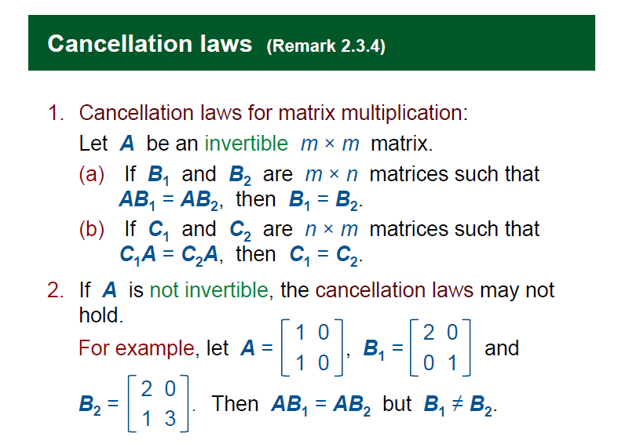

**Theorem 2.3.9 – properties of inverse**

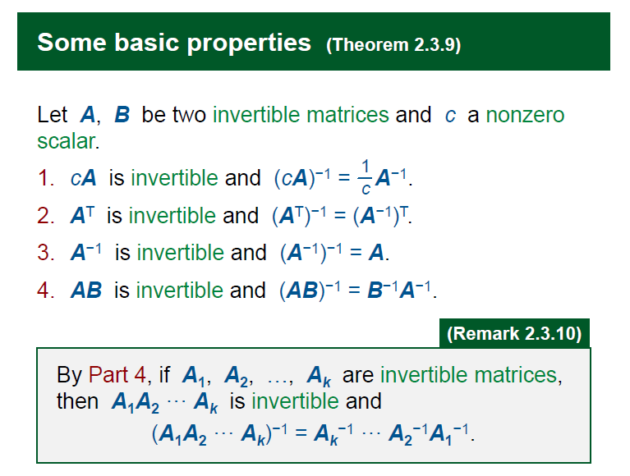

**Theorem 2.4.7 – Invertible matrices equivalence**

Let A be a n×n matrix. The following statements are equivalent:

1. A is invertible.

2. The linear system Ax = 0 has only the trivial solution.

3. The reduced row-echelon form of A is an identity matrix. -> No zero rows

4. A can be expressed as a product of elementary matrices.

5. det(A) ≠0.

6. The rows of A form a basis for n.

7. The columns of A form a basis for n.

8. Rank(A) = n

9. 0 is not an eigenvalue of A

**Theorem 2.5.10**

det(**A**T) = det(**A**)

**Theorem 2.5.15 - Effect of elementary row operations on the determinant**

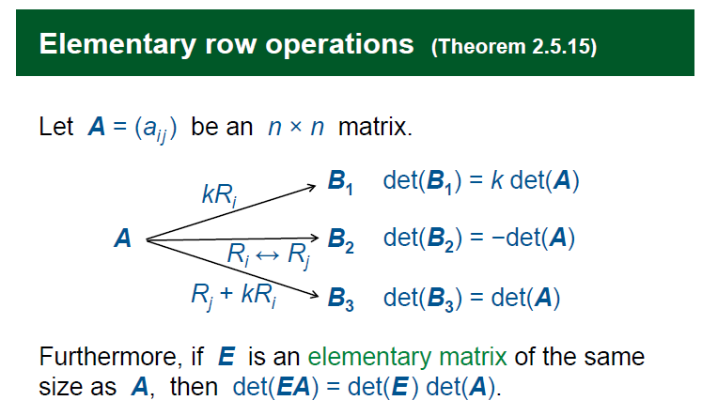

**Theorem 2.5.22.3**

det(**A**-1) =

**Adjoints 2.5.24**

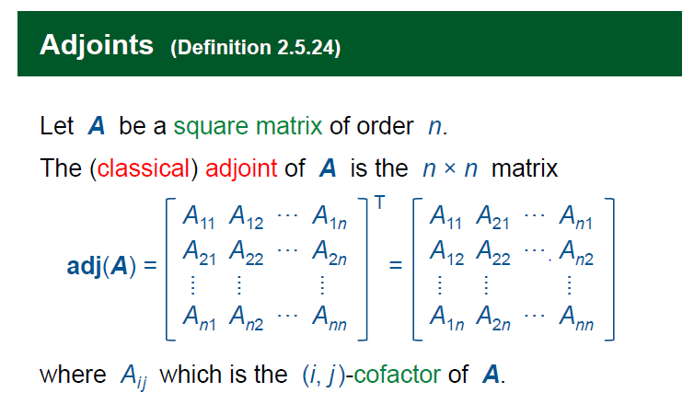

If **A** is an invertible matrix,

the **A**-1 = adj(**A**)

**Theorem 2.5.27 - Cramer’s Rule**

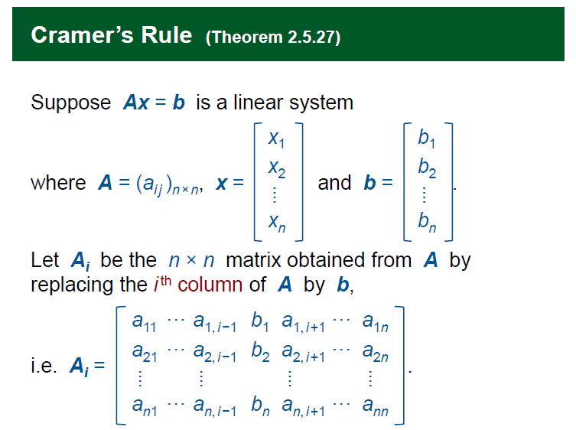

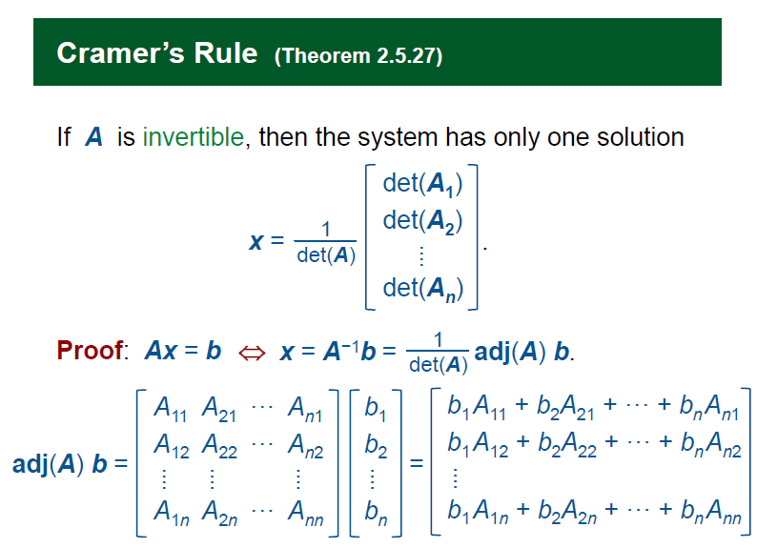

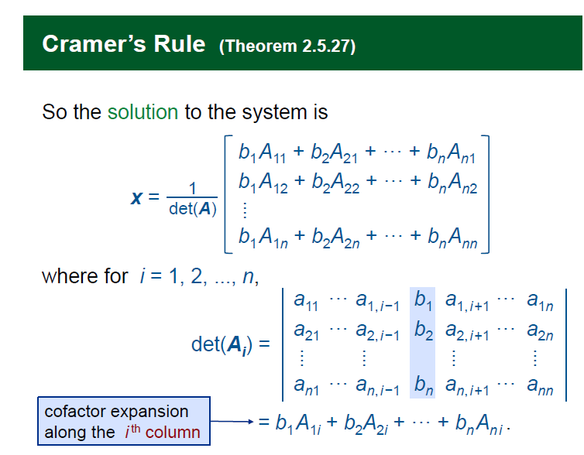

**Chapter 3 – Vector Spaces**

**Discussion 3.2.5**

To prove Span(S) = Rn 🡪 Use rref

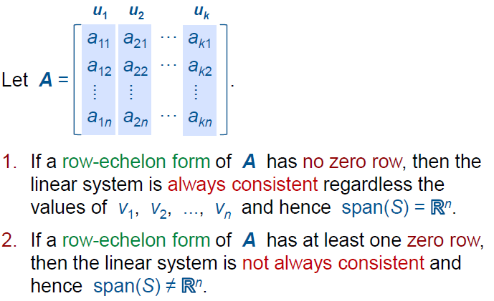

**Definition 3.3.2 – Subspaces**

Let V be a subset of Rn

V is called a subspace of Rn

If V = Span(S), where S = {u1, u2, …. uk} for u1, u2, …. uk ∈ Rn

**From theorem 3.2.9 – properties of subspace**

Let V be a subspace of Rn

1. 0 ∈ V (V must contain the origin)
2. For any v1, v2, …, vr ∈ V and   
   c1, c2, …, cr ∈ R,   
   c1v1 + c2v2 … +crvr ∈ V

**Vector space**

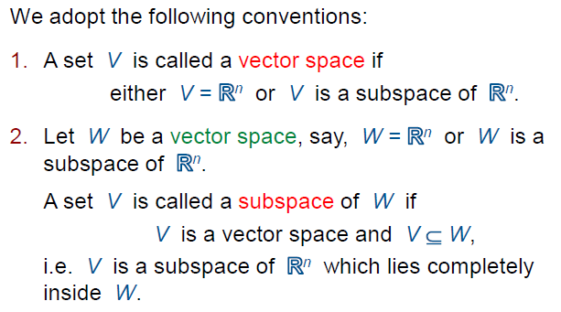

***Basis –***

Let V be a vector space

Let S = {u1, u2, …. uk} a subset of V

Then S is called a Basis for V if

1. S is linearly independent
2. S spans V

[Most Effective Span]

*Coordinate System*

You must understand yourself

**Theorem 3.6.7**

If we want to check that S is a basis for V, and we know the dimension of V is K.

we only need to check any two of the three conditions:

1. S is linearly independent;
2. S spans V;
3. |S| = k.

***Transition matrix –***

Convert the coordinates from one basis to another basis.

S = {u1, u2, u3 … uk}

T = {v1, v2, v3 … vk}

[w]­T = P [w]S -> convert a vector from basis S to basis T

P = [[u1]T [u2]T … [uk]T]

**Chapter 4 – Vector Spaces Associated with Matrices**

**Remark 4.1.9 => Finding Basis of A using Row Vectors.**

Let A be a matrix and R a row-echelon form of A.

*So, basis of A are the non-zero rows of R.*

**Properties of column Vectors**

Linear Independence of Column Vectors are preserved after row operations

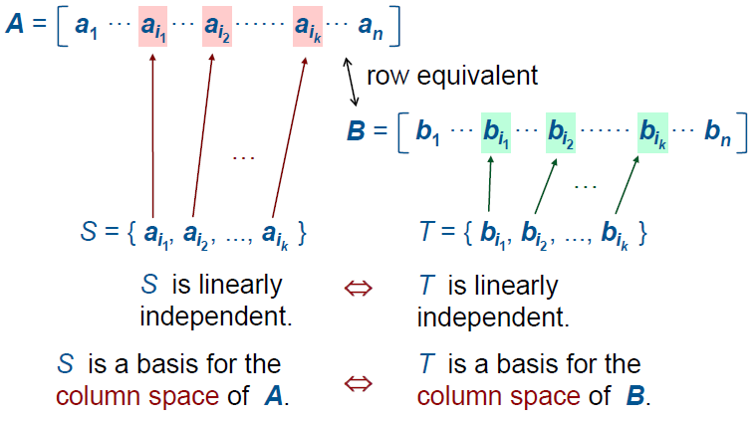

**Finding Basis of A using Column Vectors.**

A -Gaussian Elimination -> R

* Column space of R =/= column space of A
* *The basis for the column space of A can be obtained by taking columns of A that correspond to the pivot columns in R*
* Every non pivot column is a linear combination of other columns.

**Definition 4.2.3 – Rank**

The rank of a matrix is the dimension of its row space or its column space

**Theorem 4.2.8 – Ranks of product of matrices**

Let A and B be m × n and m × p matrices respectively. Then:

rank(AB) ≤ min{ rank(A), rank(B) }.

**Nullspace**

The solution space of the homogeneous linear system Ax = 0is known as the nullspace of A.

The dimension of the nullspace of A is called the nullity of A and is denoted by nullity(A).

Nullity -> the non pivot column of R

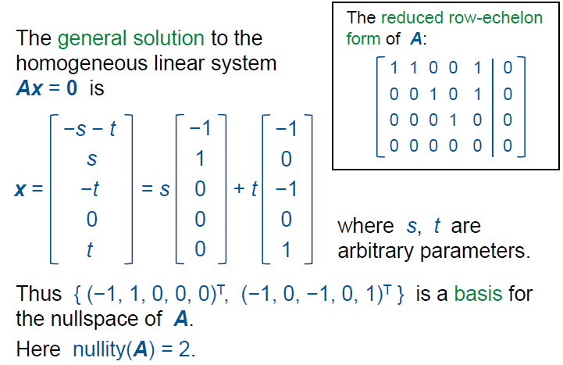

Rank(A) + nullity(A) = no. of column of A

**Chapter 5 – Orthogonality**

Dot Product is like matrix multiplication.

Should know by heart.

Distance -> U1 . U1

Angle = cos-1 ()

Orthogonal – 90 degree between the two vectors (perpendicular)

Orthogonal sets are linearly independent

Orthonormal set: a set of vectors all of which are orthogonal with each other, and each have norm (length) 1.

**Theorem 5.2.8.1 Orthogonal basis**

It is easy to get the coordinate vector of w. If S = {u1, u2, ... uk}

W = $\frac{w.u1}{u1. u1}u1+ \frac{w.u2}{u2.u2}u2 …+ \frac{w.uk}{uk.uk}uk$

[w]s = ()

A vector u is said to be orthogonal to V if u is orthogonal to all vectors in V. (the Basis of V, or any spanning set). If u is orthogonal to these, then it is orthogonal to V.

**Projection**

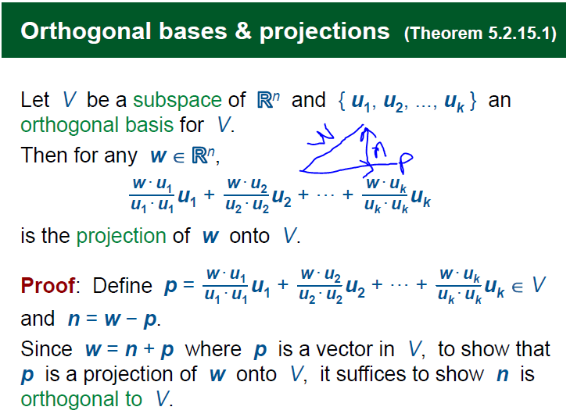

P is clearly in V

To proof n is orthogonal to V

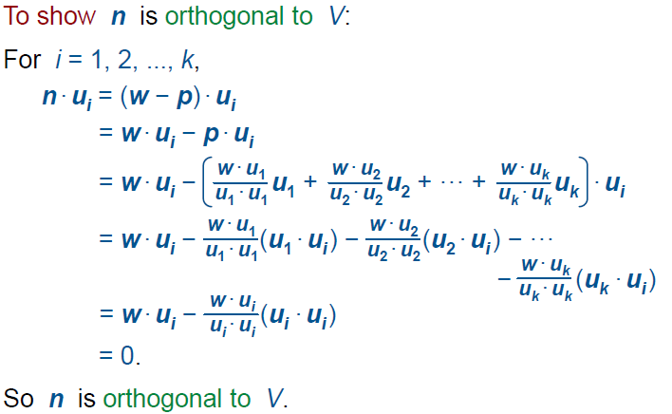

The projection of u to V is p.

The vector p is the best approximation of u in V.

**Theorem 5.2.19**

**Gram – Schmidt process**

Make any basis into an orthogonal Basis

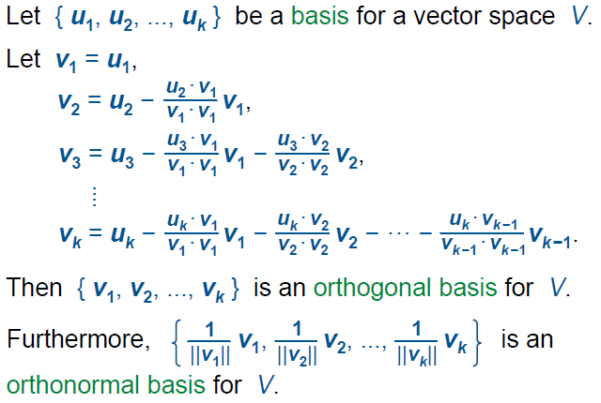

**5.3 Best Approximations**

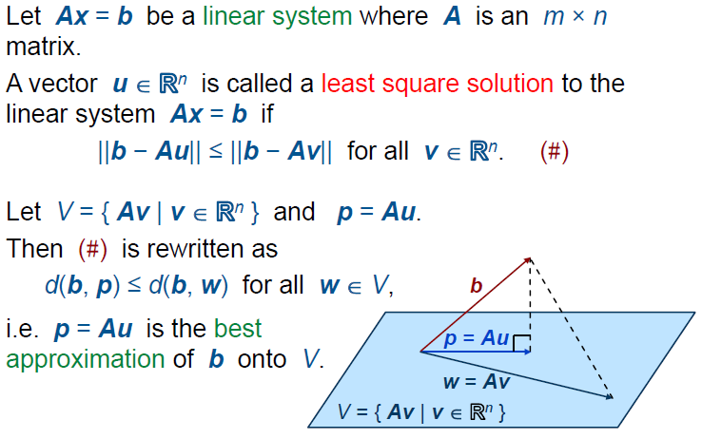

The best approximation to the equation Ax = b.

The least Square Solution is **u**

Where Au = p.

*Where p is the span of the column space of A*

**To solve least square:**

Alternatively, u is a solution to the equation



Using this method, we can find the projection of b onto A.

Since p = Ax. If x has infinitely many solution (an arbitrary parameter) take any solution to get Ax = p.

**5.4 – Orthogonal Matrices**

An orthogonal Matrix has the property P-1 = PT

Given two orthonormal bases

E = {e1, e2, … ek}

S = {u1, u2, … uk}

The transition Matrix from E to S is P. The Transition matrix from S to E is Q.

P is QT

(By theorem 3.7.5) => Q = P-1

So, P-1 = PT

To find:

**Theorem 5.4.6 – orthogonal matrices**

1. A is orthogonal
2. The rows of A form an orthonormal basis for Rn
3. The columns of A form an orthonormal basis for Rn